# Technical Design Document: Programming Exercise 3

# Name: Lucas Korzeniewski
# Date: June 21, 2026
# Program Description: This program allows a user to enter a list of monthly expenses by providing the expense type and the expense amount. The program stores the expenses in a list of tuples and uses the reduce() function from Python's functools module to analyze the data. The program calculates the total monthly expenses, identifies the highest expense and its label, and identifies the lowest expense and its label
## Function: get_expenses()
Prompts the user to enter expense types and amounts. The function stores the information in a list of tuples and returns the completed list.
Parameters:
None
Variables:
expenses (list of tuples (str, float))
count (integer)
expense_type (string)
expense_amount (float)
Logic:
- Create an empty list named expenses.
- Repeat for the number of expenses specified by the constant NUMBER_OF_EXPENSES.
- Ask the user to enter the expense type.
- Ask the user to enter the expense amount.
- Store the expense type and amount as a tuple in the list.
- Return the completed list of expenses.
Return:
expenses (list of tuples containing expense names and amounts)
## Function: calculate_total(expenses)
Calculates the total amount of all monthly expenses using the reduce() function.
Parameters:
expenses - list of tuples (str, float)
Variables:
total_expense (float)
Logic:
- Use reduce() to iterate through the list of expenses.
- Add each expense amount to an accumulating total.
- Store the result in total_expense.
- Return the total amount.
Return:
total_expense (float)
## Function: calculate_highest(expenses)
Determines which expense has the highest amount using the reduce() function.
Parameters:
expenses (list of tuples (str, float))
Variables:
highest_expense - tuple (str, float)
Logic:
- Use reduce() to compare two expense tuples at a time.
- Keep the tuple with the larger expense amount.
- Continue until all expenses have been compared.
- Return the tuple containing the highest expense.
Return:
## Function: calculate_lowest(expenses)
Determines which expense has the lowest amount using the reduce() function.
Parameters:
expenses (list of tuples (str, float))
Variables:
lowest_expense (tuple (str, float))
Logic:
Use reduce() to compare two expense tuples at a time.
Keep the tuple with the smaller expense amount.
Continue until all expenses have been compared.
Return the tuple containing the lowest expense.
Return:
lowest_expense (tuple containing expense name and amount)
## Function: display_results(total_expense, highest_expense, lowest_expense)
Displays the total monthly expenses, the highest expense with its label, and the lowest expense with its label.
Parameters:
total_expense (float)
highest_expense (tuple (str, float))
lowest_expense (tuple (str, float))
Variables:
None
Logic:
- Display the total monthly expenses.
- Display the highest expense name and amount.
- Display the lowest expense name and amount.
Return:
None
## Function: main()
Serves as the main control function for the program. It coordinates the collection of expenses, performs calculations, and displays the results.
Parameters:
None
Variables:
expenses (list of tuples (str, float))
total_expense (float)
highest_expense (tuple (str, float))
lowest_expense (tuple (str, float))
Logic:
- Call get_expenses() to collect user input.
- Call calculate_total() to determine the total expenses.
- Call calculate_highest() to find the highest expense.
- Call calculate_lowest() to find the lowest expense.
- Call display_results() to display the results.
Return:
None
#Link to your repository: https://github.com/lucask333?tab=repositories
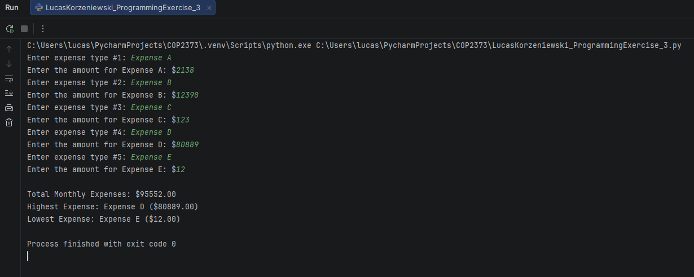
Output Screenshot: (make sure big enough so I can see)

